1. Instrument Choice
Core rule: Measurable emissions → Tax / Cap-and-Trade, Not measurable → Technology Mandate
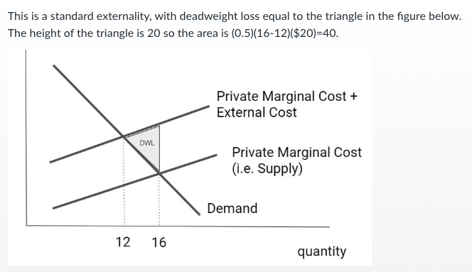
Applications: CO₂ (power plants) → Tax / Cap, Fly ash → Mandate, Principal-agent → Standard, Information gap → Label / Disclosure

2. Externalities
Private equilibrium (PE): MB = MPC, Social optimum (SE): MB = MPC + MEC
Deadweight loss (DWL): 0.5 × (Q_market − Q_social) × MEC
Negative externality → overproduction → DWL triangle
Pigouvian tax = set tax = externality → efficient quantity Q*
3 Market Failure(solution):
1. Unpriced Externalities (unpriced social damages)-> Price them (Pigouvian tax),
2. Imperfect information -> Provide info (EnergyGuide / ENERGY STAR),
3. Principal-agent (landlord underinvest as they don’t pay u-bill)-> problem Minimum efficiency standards

3. Electricity Market
Merit order (low → high cost): Renewables → Nuclear → Coal → Gas
Market price: Price = MC of marginal unit, Producer surplus: PS = Price − MC
Fossil fuels usually set price

4. Carbon Policy Effects
Carbon tax: Raises fossil MC Shifts supply up Fuel switching Price usually increases (depends on marginal unit)
Offsets: Increase compliance options Permit price ↓ Electricity price ↓ Low-cost generator profit ↓
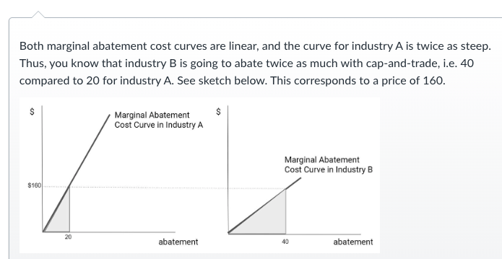
Permit allocation: Free permits → distort exit, Auction → efficient
Opportunity cost: Free permit ≠ zero cost; cost = market price; same regardless of how they are allocated
5. Leakage vs Reshuffling
Leakage → policy made production moves outside regulated region, Reshuffling → trading partners change, production unchanged

6. Cap-and-Trade (Two Firms)
Equalize MAC: MAC_A = MAC_B = P, Total: X_A + X_B = Total, Solve by equating MACs and using total constraint. More abatement by the lower-cost (flatter MAC) firm, Total cost = area under MAC curves (triangles)
MAC < Permit → Abate /MAC > Permit → Buy

8. Behavioral Failures
Rebound effect → efficiency ↑, usage ↑ , Principal-agent → decision-maker ≠ payer, eg: landlord don’t invest (tenant pays utility
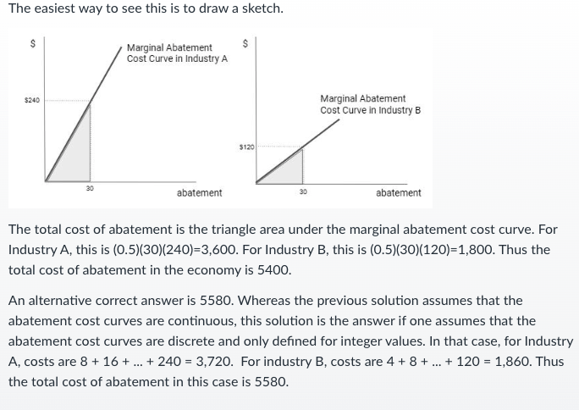
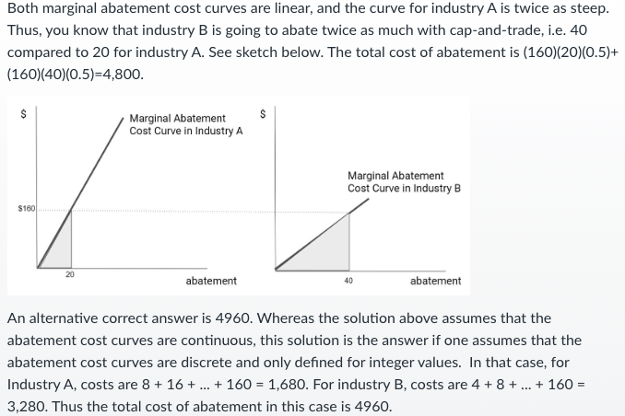
9. Fuel Economy Standard (CAFÉ): Applies to fleet average Compliance via 1.technology improvements and 2.sales mixcredit trading → can sell over-compliance → stronger incentives (improves efficiency)

Policy | What it Fixes | Price | Emissions | Efficiency
Carbon Tax | Price | Fixed | Uncertain | High
Cap-and-Trade | Quantity | Uncertain | Fixed | High
Technology Standard | Technology / Behavior | None | Fixed / Indirect | Low
Subsidy | Behavior (Incentives) | None | Uncertain | Medium
Command-and-Control | Quantity / Method | None | Fixed | Low
LCOE=constant price per MWh that makes NPV = 0 (折線後的cost /折線後總電量) If MC fixed: 1.Discount electricity 2. Fixed cost ÷ discounted electricity 3. +MC. If MC varies: 1.Discount costs with varied MC + fixed cost 3. Discount electricity 4. Discounted Total cost(1)/ discounted total electricity(3)
Limitation: LCOE ignores time, location, and dispatchability, treating all electricity as equally valuable.
LCOE= MC+ (Fixed cost/Discounted Electricity), if capacity increases, LCOE decreases.

